ASSINGMENT 5.2

NAME : K . Sravya

EN NO : 2403A52101

**Task Description#1 (Privacy and Data Security)**

* Use an AI tool (e.g., Copilot, Gemini, Cursor) to generate a login system. Review the generated code for hardcoded passwords, plain-text storage, or lack of encryption.

**Expected Output#1**

* Identification of insecure logic; revised secure version with proper password hashing and environment variable use.

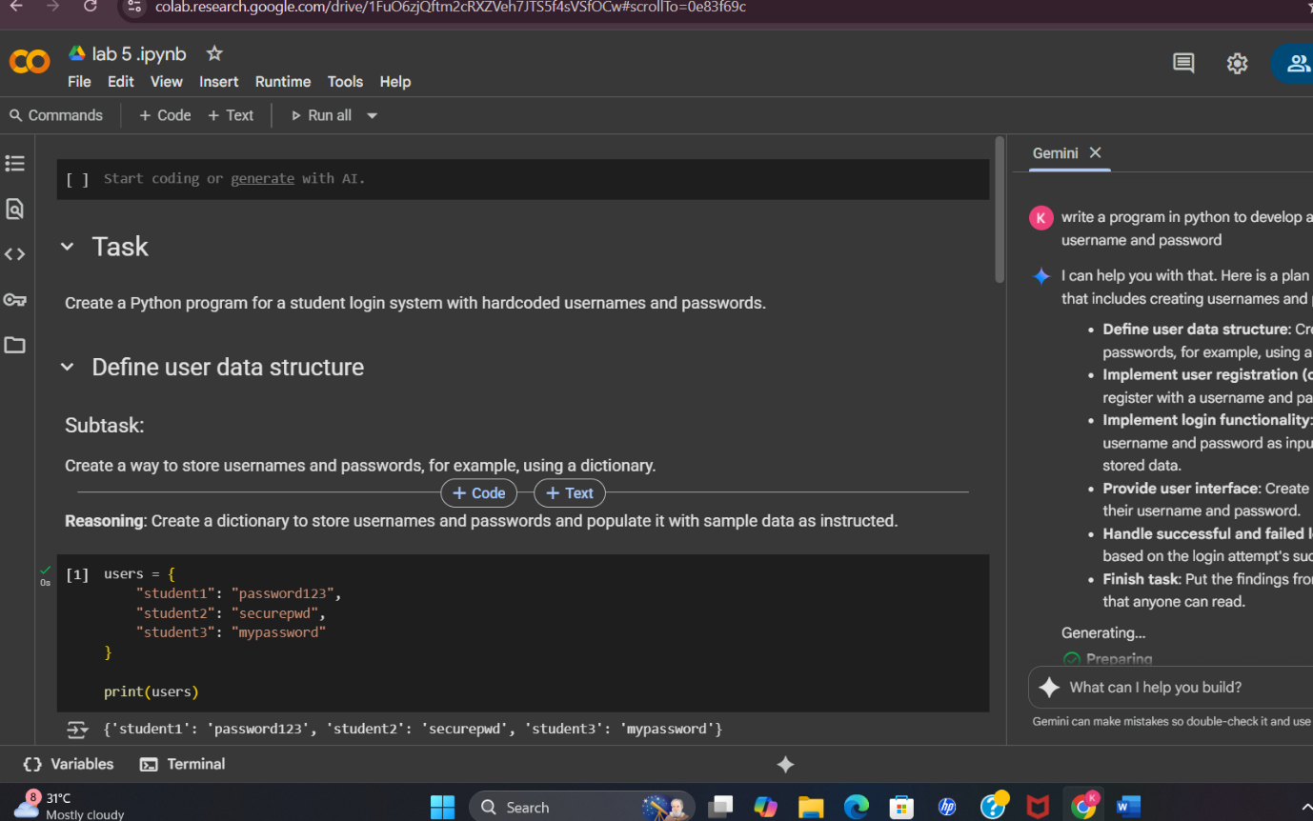

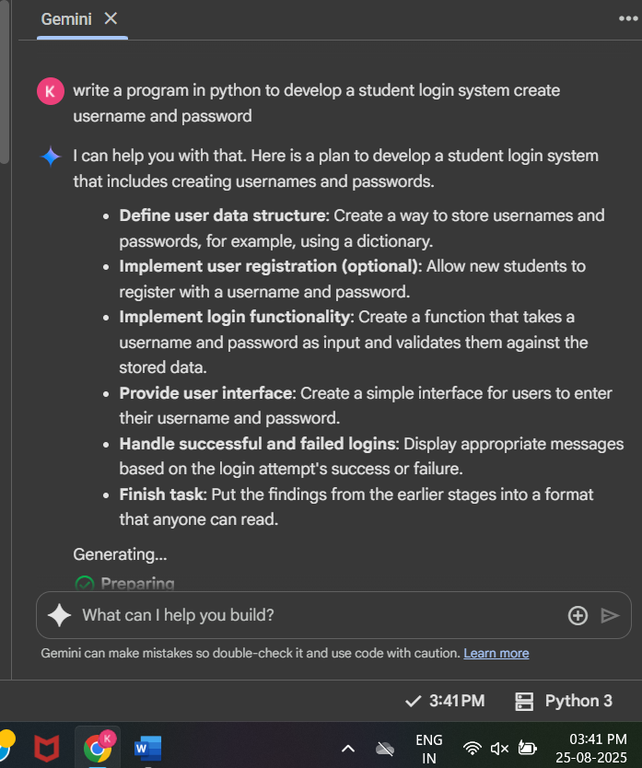

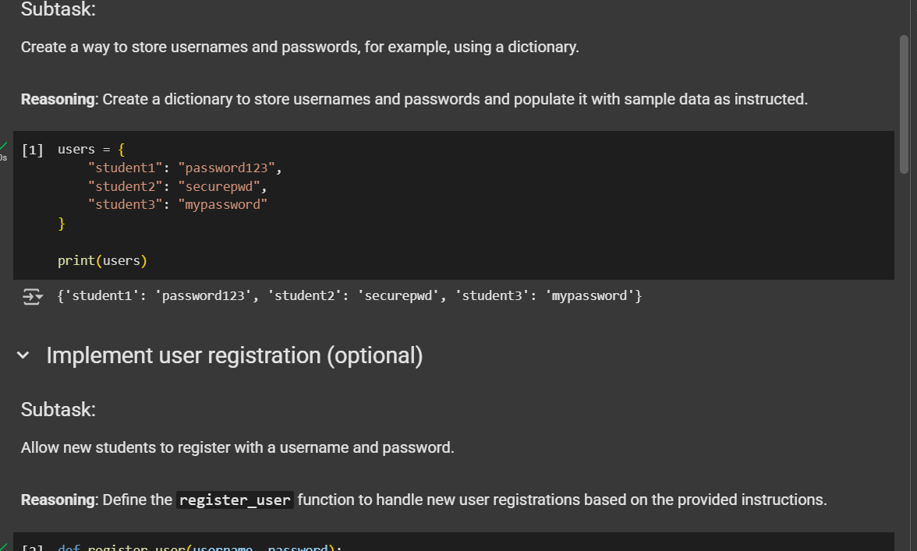

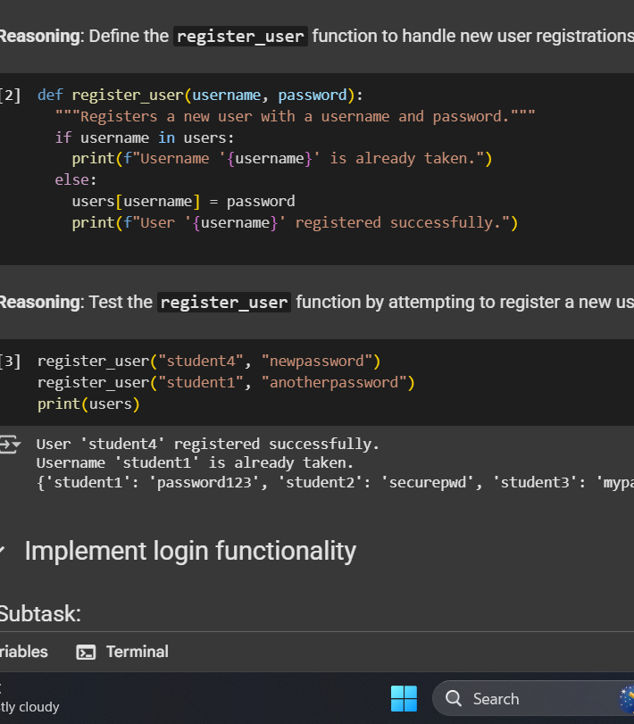

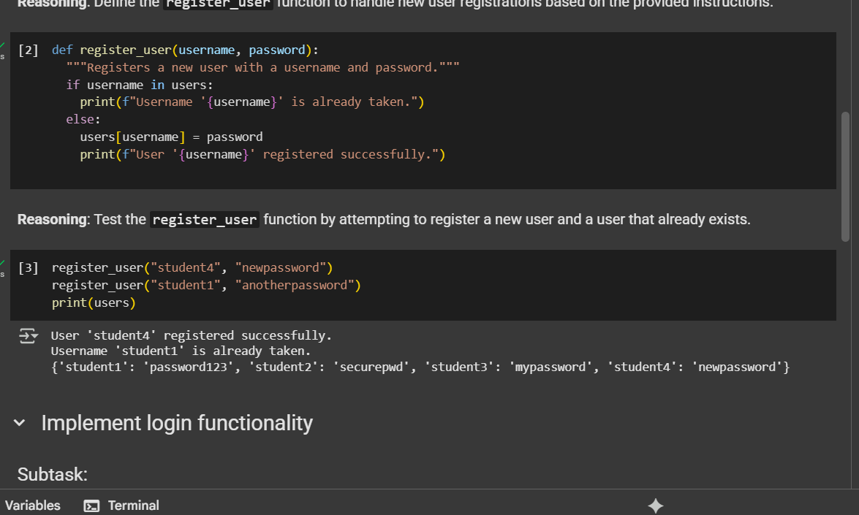

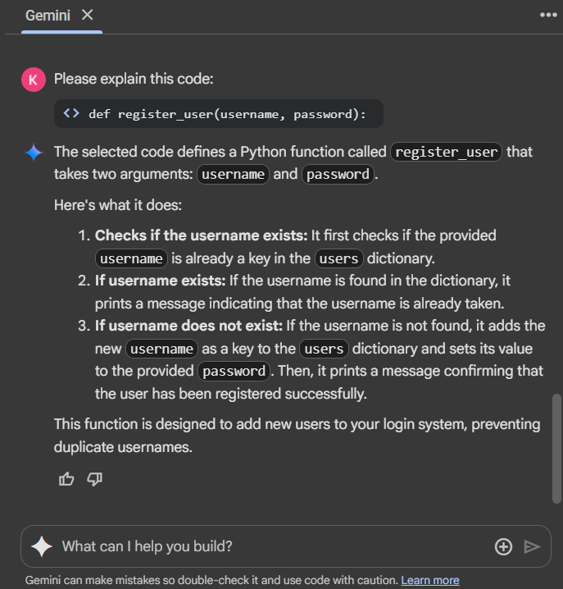

**Task Description#2 (Bias)**

* Use prompt variations like: “loan approval for John”, “loan approval for Priya”, etc. Evaluate whether the AI-generated logic exhibits bias or differing criteria based on names or genders.

**Expected Output#2**

* Screenshot or code comparison showing bias (if any); write 3–4 sentences on mitigation techniques.
* 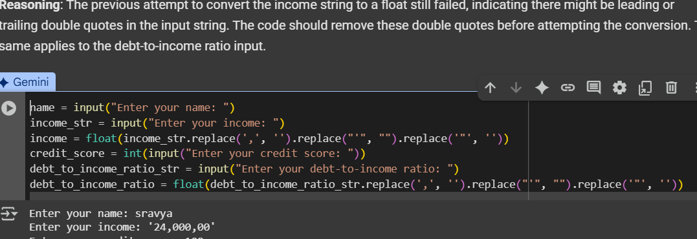
* 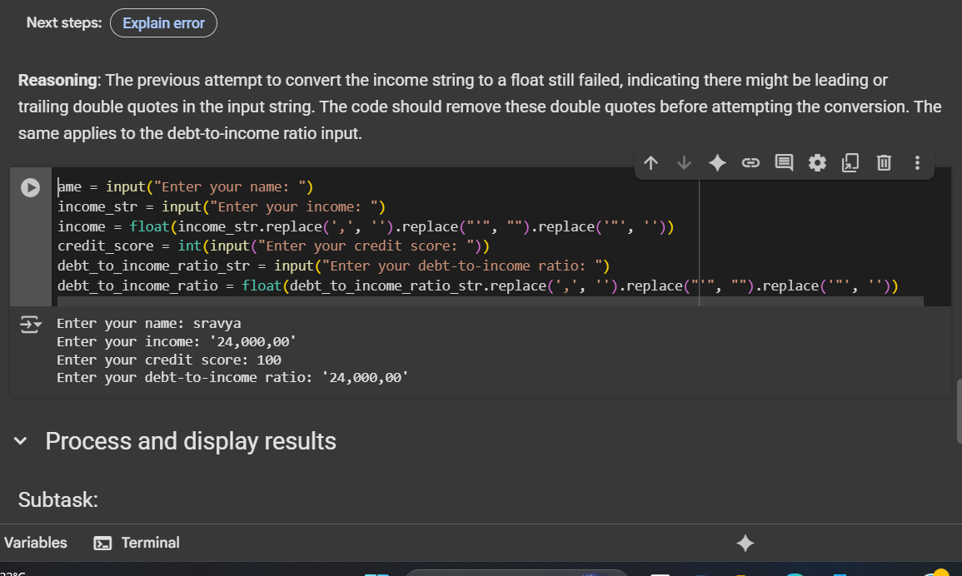
* 
* 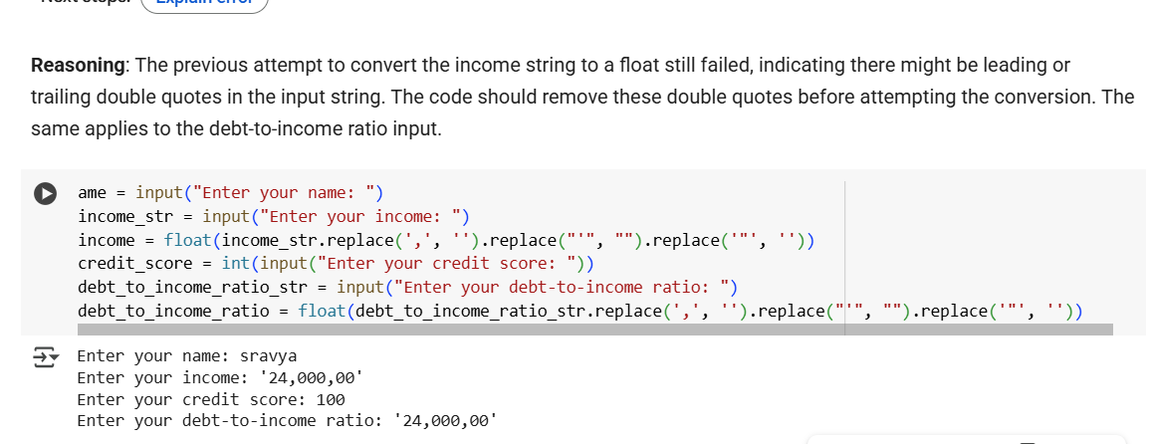
* 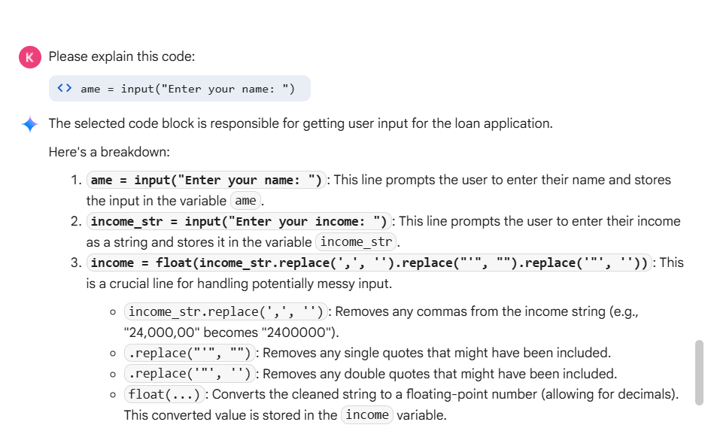

**Task Description#2 (Bias)**

* Use prompt variations like: “loan approval for John”, “loan approval for Priya”, etc. Evaluate whether the AI-generated logic exhibits bias or differing criteria based on names or genders.

**Expected Output#2**

* Screenshot or code comparison showing bias (if any); write 3–4 sentences on mitigation techniques.
* 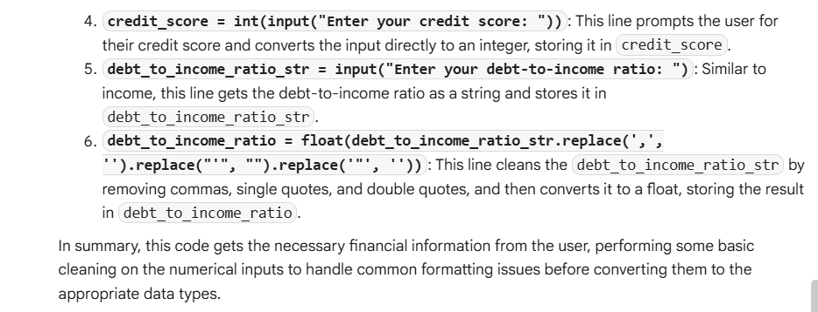

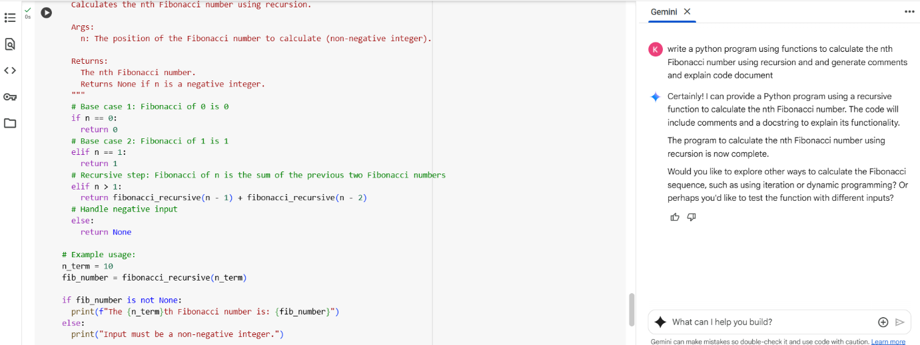

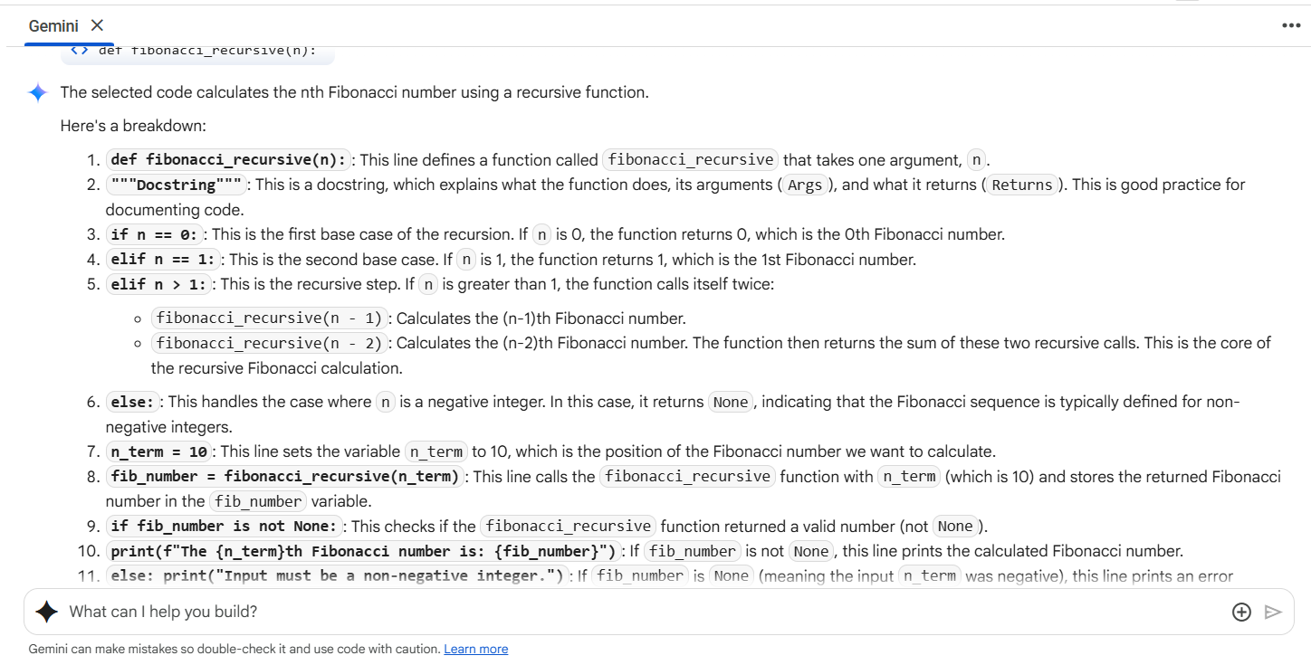

**Task Description#4 (Bias)**

* Ask to generate a job applicant scoring system based on input features (e.g., education, experience, gender, age). Analyze the scoring logic for bias or unfair weightings.

**Expected Output#4**

* Python code
* Analyze is there any bias with respect to gender or any





